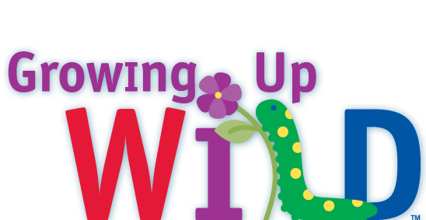

Growing Up WILD Workshop Proposal
Maryland

Your name:

Title or position:

Mailing address (for books):
City:
Zip:
Phone:
Fax:

Proposed workshop details-

DATE(S):
TIMES:
LOCATION:
# OF PARTICIPANTS:
Describe intended audience:

Number of Growing Up WILD guides needed:

Date by which materials should arrive:

Other information:

Proposed workshop format and tentative agenda: (please use the back of this sheet or attached another sheet, if needed, and include activities that you will go over in your workshop).

_____________________________________________________________________

Please email, fax or mail this proposal at the earliest date in advance of the workshop (4 weeks prior is recommended) to Sarah Witcher, sarah.witcher1@maryland.gov or Wildlife and Heritage Service, 580 Taylor Ave., E-1, Annapolis, MD 21401, or fax 410-260-8596. Questions? Please call 410-260-8566.

