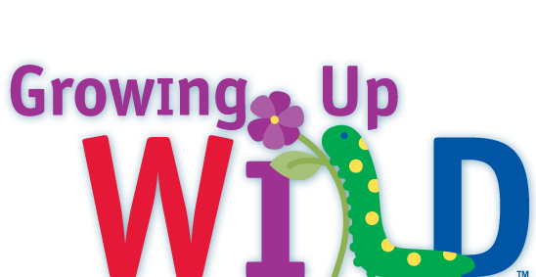

Growing Up WILD Workshop Proposal

Maryland

**Your name**:

**Title** or position:

**Mailing address** (for books):

City:

Zip:

Phone:

Fax:

**Proposed workshop details-**

DATE(S):

TIMES:

LOCATION:

# OF PARTICIPANTS:

Describe intended audience:

**Number of Growing Up WILD guides needed**:

Date by which materials should arrive:

Other information:

**Proposed workshop format and tentative agenda**: (please use the back of this sheet or attached another sheet, if needed, and include activities that you will go over in your workshop).

_____________________________________________________________________

Please email, fax or mail this proposal at the earliest date in advance of the workshop (4 weeks prior is recommended) to Sarah Witcher, [sarah.witcher1@maryland.gov](mailto:sarah.witcher1@maryland.gov) or Wildlife and Heritage Service, 580 Taylor Ave., E-1, Annapolis, MD 21401, or fax 410-260-8596. Questions? Please call 410-260-8566.