Maryland Park Service Training Division
Course Registration (New Procedures)

Background
We have been working for more than a year and a half with DoIT and others to find a way of making our course registration more efficient. I believe we have found a way to do it within Google Apps. As our new website is not quite ready, I have given everyone access to the mps.trainingdivision Google calendar. (It has been made public and searchable.) Once our site is ready, this calendar will be linked to the training website. Until then, and even after if you wish, you will be able to see the mps.trainingdivision calendar in your list of available calendars.

Adding a Google Calendar to your “other calendars”.
You can only add a calendar using a link if the other person's calendar is public.
- Open Google Calendar.
- On the left side, find "Other calendars" and click the down arrow .
- Select Add by URL.
- Enter the calendar's address in the field provided. The address needs to be an ICAL link. Here is the address: https://calendar.google.com/calendar/ical/mps.trainingdivision%40maryland.gov/public/basic.ics
- Click Add calendar.

Here is how it works.

The mps.trainingdivision calendar has been made public, so now anyone with a gmail account can access the calendar. We strongly encourage volunteers who wish to access this calendar once it is available on the training website – to create a gmail account and access the website with that account. They will have access to more of the features on the website if they have a gmail account.

You may view the calendar in any format that you wish. In this job aid we will view the calendar in the “month” format.

Step 1 – Browse the Calendar for Training that is of interest.
Step 2 – When you find a training opportunity – If you click on it you will get a pop-up window that gives you some basic information. However, to see the full course information you will need to double click on the training listing.
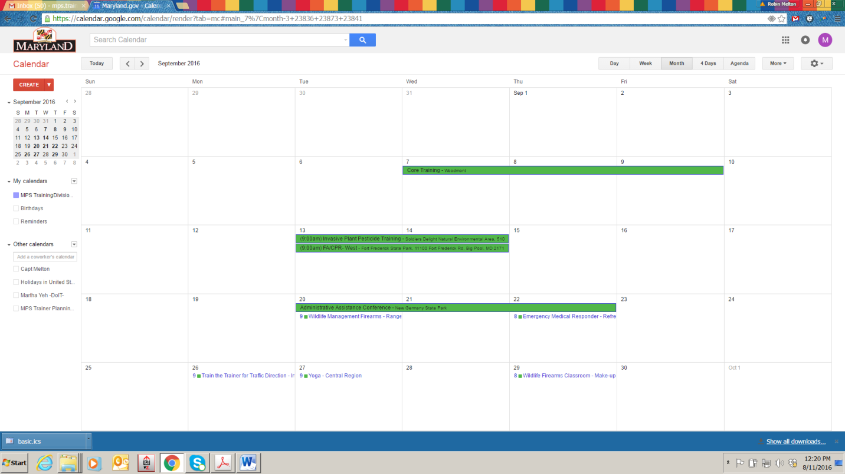
Here you see all of our Fall classes for the Month of September that have been loaded.
Classes in dark green are multi-day classes.
Classes with the small green box by them are single day classes.
Example: When you double click on the FA/CPR Class on September 18th – you will see the full details of the class. Example Below:

Here you will see the class details. Class Description, Date, Time, Location. You will also see an “Attachment” just below the description.
Step 3 - If you want to register for the class, you will click on that attachment to open the document.

When you click on the attachment you will be taken to a Google Form.
Please note: If you’re accessing from a regular gmail account (not a Maryland.gov account) and you can’t see the form – please contact the training division, so we can give you access to the form.
This form looks the same for every class.
Step 4: Students will enter:
Their email address – this field was added as emails are only captured as usernames for Maryland.gov accounts.
Last Name
First Name
Select your classification from a drop down menu.
Select your current Park/Location assignment from a drop down menu.
Indicate if you would like a copy of the form sent to you.
Finally, Click Submit.

Step 5 -You will then receive a confirmation email:

This will be the only email you receive – the training division will not be sending out any additional confirmation emails.

When you log out of the calendar and back in – you will see yourself listed as a guest in the course.

The event will now show up in your primary Google calendar.

At this point – if we make any changes to this class posting – you will automatically receive those updates via email notification.

Withdrawing from a course
You can remove yourself from the guest list, and it will in-turn remove it from your calendar, if you wish to withdraw from the class. We also ask that you contact the training division if you do this, as it does not update the Google Form or the Spreadsheet associated with the course, and this is what we will be sharing with instructors. Also class members and instructors can see who is in the course by looking at the guest list at any time.
When courses have a maximum class size, you will be able to see if there is room in the class before you register. It will not prevent you from registering, however your submission is time stamped and we will notify you of a wait list status via email. You will also be able to see courses that are in danger of cancellation for not meeting the minimum level of 6 people for registration.

The Course roster will be a Google Sheets document that we will be able to download and print for sign-in during the class.

You may reach out directly to Robin Melton for assistance at 443-534-1990 or robin.melton@maryland.gov.

Sarah Gray will also be available to assist you when she returns on contract in mid-September.
410-260-8159 or sarah.gray@maryland.gov.

We understand that some of you may not currently be active users of Google Calendar, below you will finds some links to helpful tutorials on how Google Calendar works.

https://apps.google.com/learning-center/products/calendar/#/list

https://www.youtube.com/watch?v=C-G2BLFVJ-c

