Land and Water Conservation Fund

OPEN PROJECT SELECTION PROCESS (OPSP)
for State Projects

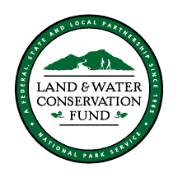

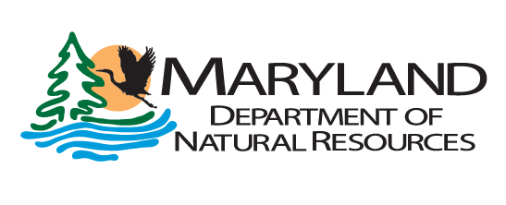
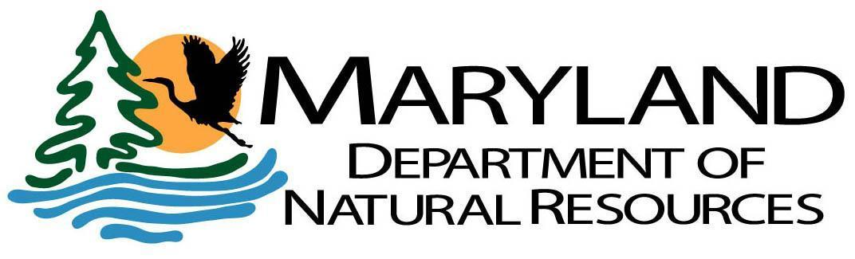

LAND AND WATER CONSERVATION FUND

Background
Authorized by the United States Congress and signed into law by President Lyndon Johnson, the Land and Water Conservation Fund Act of 1965 established a federally funded program to provide 50/50 matching grants to state and local governments for the purpose of acquiring and/or developing public outdoor recreational areas and facilities. The program is administered nationally by the United States Department of the Interior, National Park Service with the supporting revenues generated from offshore oil and gas leases. The Land and Water Conservation Fund is intended to create and maintain a nationwide legacy of quality public outdoor recreational resources as well as to stimulate non-federal investments in the purchase, development, maintenance and protection of these highly valued outdoor recreational areas. Per section 6(f)(3) of the Land and Water Conservation Fund Act, “No property acquired or developed with assistance under this section shall, without the approval of the Secretary of the Department of the Interior, be converted to other than public outdoor recreation uses.”
The Land and Water Conservation Fund is managed at the state level, by the state governments. In order to be eligible to receive a program apportionment from the National Park Service, each state must develop and maintain a Statewide Comprehensive Outdoor Recreation Plan and appoint an official State Liaison Officer. All eligible projects must reflect the states’ policies and priorities of its most current Statewide Comprehensive Outdoor Recreation Plan; in Maryland this plan is the Maryland Land Preservation and Recreation Plan. Municipalities, counties, and state agencies may apply for up to 50 percent matching fund assistance from the Land and Water Conservation Fund. In Maryland, the Department of Natural Resources, Land Acquisition and Planning Unit, is responsible for managing the program, coordinating grant rounds for project funding, and monitoring past project sites for program compliance in Maryland. Since its inception, the Land and Water Conservation Fund program has funded over 350 acquisition and development projects throughout the state of Maryland.

Project Selection Overview
Assistance will be granted to state and local governments for the purpose of acquiring and/or developing public outdoor recreational areas and facilities. A proposed project must meet a priority outdoor recreation need as identified in the current Maryland Land Preservation & Recreation Plan (LPRP), which serves as the Maryland SCORP. The goals and strategies identified in the Maryland LPRP can be found at the end of this document.

As per these OPSP Guidelines, and pending DNR approval, successful applicants may amend projects to increase the cost of a state sponsored project, including the federal share, without further OPSP competition.

For details on LWCF background, project eligibility, grantee compliance and commitments, and grant application process, please read the ‘Land and Water Conservation Fund, MD Grant Application Information packet.

Project Scoring Criteria for MD Land and Water Conservation Fund State-Side

1. Purpose and Need: to what extent does the proposal meet recreational needs identified in the current Maryland Land Preservation and Recreation Plan? (37 points max)

a. The project promotes the economic, cultural, health, and environmental benefits of outdoor recreation and conservation of natural lands. The project assists in increasing the public's understanding of these benefits to enhance interest and participation in recreating outdoors in Maryland. (Goal: Promotes the Benefits of Outdoor Recreation and Conservation of Natural Lands ) (0-2 points)

b. The project increases and improves opportunities for all segments of the population to access land and water-based outdoor recreation opportunities. (Goal: Increases Access to Open Spaces and Waterfronts) (0-12 points)

c. The project improves the overall quality of outdoor recreation infrastructure at public parks and outdoor areas across the state. (Goal: Improve What’s Already Available) (0-12 points)

d. The project promotes environmental education and use of parks and outdoor areas as teaching tools to foster a positive stewardship ethos among children, youth, and their families. (Goal: Develop an Informed Stewardship Culture) (0-5 points)

e. The project meets general goals, actions, and strategies of the Maryland LPRP. (0-6 points)

2. Conservation Value - Consistency and Benefit (8 points max)

a. For Acquisition Project Only: recreational use is consistent with, will maintain, or will improve, the ecological value of the parcel. Project provides natural resource conservation and helps to protect natural open spaces and resources. Ecological value will enhance/protect wildlife habitat, rare species, aquatic life, forest/water quality, falls in a Targeted Ecological Area, provides a restoration opportunity, protect historic/cultural resources (if any); and/or is in a climate change adaptation area; (see DNR Stewardship Report). (0-8 points)

b. For Development Project Only: recreational use is consistent with, will maintain, or will improve, the ecological value of the parcel; development project will not disturb/negatively impact ecological value of the project area; ). (0-8 points)

3. To what extent is the project ready to proceed? (29 points max)
a. Development Projects that are considered ‘shovel-ready’ because the following work is complete or will be completed prior to notification of award: conceptual and design development phases; final construction plans. Does this project include design and planning, and construction, or just construction? If the project does include design and planning, has an RFP been sent out to a design and engineering firm? Where in the process is the RFP? In addition the application indicates the applicant is able to complete the NEPA process and bid and award construction in a timely manner. (0-15 points) (score a or b)

Note: Projects score higher when all the design and engineering is complete but E&C can apply for design planning and engineering. If E&C is applying for design planning and engineering they will still need to include a well developed cost estimate for development in their preliminary and NPS application.

b. Acquisition Projects that are ‘project ready’ because the following work has been completed: have UASFLA or ‘Yellow Book’ appraisal(s) (cannot be older than one year from project submission) and application indicates the applicant is ready to acquire the property. (0-15 points) (score a or b)

c. How realistic is the timeline provided? Will the project applicant complete the project within 3 years and is that clear in the timeline provided? How specifically will the project site be open to the general public within three years? (0-9 points)

d. The application includes evidence of public comment/engagement, or an explanation of how public comments/engagement will be conducted prior to the start of the project. (0-5 points)

- Public meetings/workshops
- BPW approval/public budget process
- Public comment period
- Engagement through LPPRP process (e.g., surveys)
4. Rate the budget (12 points max)
a. Is a detailed budget submitted? (0 - 6 points)

b. Is the budget realistic? (0 - 4 points)

c. Are eligible matching funds included in the State’s capital budget? If so, in what state FY? (0 - 2 points)

5. Consistency with LWCF program (14 points max)
a. Is the project consistent with the requirements of LWCF grant assistance? Examples include: structures not in support of outdoor recreation; agriculture; indoor recreation; luxury facilities; over-head power lines; ineligible leases, easements, or property restrictions; potential conflicts with protecting the 6(f) area in perpetuity.
(0-14 points; if there are issues include in written comments below).

Total Points out of 100:

Notes/Comments/Issues with Project/Application:

State Goals for Recreation, Parks, and Open Space from Maryland’s 2019 – 2023 Land Preservation and Recreation Plan

Goal 1: Coordination and Collaboration
Strengthen coordination and collaboration between federal, state, and local government agencies and other key stakeholders in planning for the provision of outdoor recreation opportunities and land conservation initiatives.

Goal 2: Promote the Benefits of Outdoor Recreation and Conservation of Natural Lands
Promote the economic, cultural, health, and environmental benefits of outdoor recreation and conservation of natural lands. Seek to increase the public's understanding of these benefits to enhance interest and participation in recreating outdoors in Maryland.

Goal 3: Increase Access to Open Spaces and Waterfronts
Increase and improve opportunities for all segments of the population to access land and water-based outdoor recreation opportunities.

Goal 4: Improve What’s Already Available
Improve the overall quality of outdoor recreation infrastructure at public parks and outdoor areas across the state.

Goal 5: Develop an Informed Stewardship Culture
Promote environmental education and use of parks and outdoor areas as teaching tools to foster a positive stewardship ethos among children, youth, and their families.

