Land and Water Conservation Fund

OPEN PROJECT SELECTION PROCESS (OPSP) for Local Government Projects

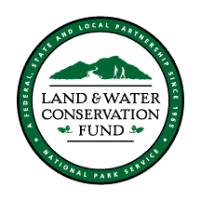

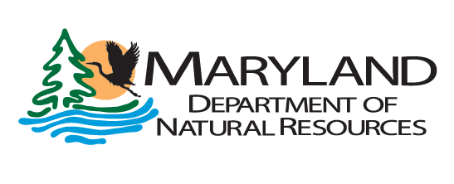
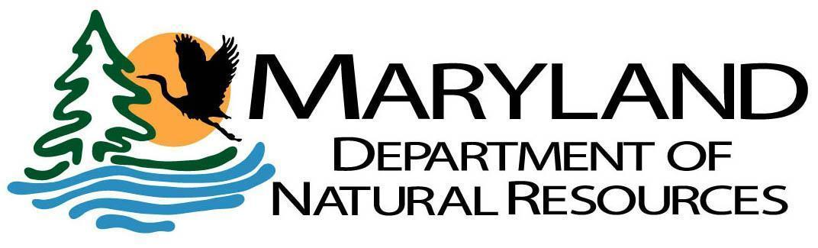

LAND AND WATER CONSERVATION FUND

Background
Authorized by the United States Congress and signed into law by President Lyndon Johnson, the Land and Water Conservation Fund Act of 1965 established a federally funded program to provide 50/50 matching grants to state and local governments for the purpose of acquiring and/or developing public outdoor recreational areas and facilities. The program is administered nationally by the United States Department of the Interior, National Park Service with the supporting revenues generated from offshore oil and gas leases. The Land and Water Conservation Fund is intended to create and maintain a nationwide legacy of quality public outdoor recreational resources as well as to stimulate non-federal investments in the purchase, development, maintenance and protection of these highly valued outdoor recreational areas. Per section 6(f)(3) of the Land and Water Conservation Fund Act, “No property acquired or developed with assistance under this section shall, without the approval of the Secretary of the Department of the Interior, be converted to other than public outdoor recreation uses.”
The Land and Water Conservation Fund is managed at the state level, by the state governments. In order to be eligible to receive a program apportionment from the National Park Service, each state must develop and maintain a Statewide Comprehensive Outdoor Recreation Plan and appoint an official State Liaison Officer. All eligible projects must reflect the states’ policies and priorities of its most current Statewide Comprehensive Outdoor Recreation Plan (SCORP); in Maryland this plan is the Maryland Land Preservation and Recreation Plan. Municipalities and counties may apply for up to 50 percent matching fund assistance from the Land and Water Conservation Fund. In Maryland, the Department of Natural Resources, Land Acquisition and Planning Unit, is responsible for managing the program, coordinating grant rounds for project funding, and monitoring past project sites for program compliance in Maryland. Since its inception, the Land and Water Conservation Fund program has funded over 400 acquisition and development projects throughout the state of Maryland.

Local Government Project Selection Overview
Assistance will be granted to state and local governments for the purpose of acquiring and/or developing public outdoor recreational areas and facilities. A proposed project must meet a priority outdoor recreation need as identified in the current Maryland Land Preservation & Recreation Plan (LPRP), which serves as the Maryland SCORP. The goals and strategies identified in the Maryland LPRP can be found at the end of this document. The project must also address local recreation need for the community and general public and be tied to the County Land Preservation, Parks, and Recreation Plans.

As per these OPSP Guidelines, and pending DNR approval, successful applicants may amend projects to increase the cost of a locally sponsored project, including the federal share, without further OPSP competition.

For details on LWCF background, project eligibility, grantee compliance and commitments, and grant application process, please read the ‘Land and Water Conservation Fund, MD Grant Application Information packet.

Project Scoring Criteria for MD LWCF Local Projects
(attach to preliminary application form)

1. Purpose and need of the proposal (30 points max)

a. Project aligns with specific goals and needs-based planning objectives from the County Land Preservation, Parks, and Recreation Plans (LPPRP) that addresses a local recreation need for the community and the general public. (0 – 12 points)

b. Recreational use is consistent with preserving, or will improve, the ecological value of the parcel. (0 – 3 points)

c. The project provides a unique recreational experience for users and application provides a clear understanding of why it should be funded. (0 - 5 points)

‘Unique’ could be thought of as the following:
- Creation of a new opportunity, either through acquisition or development
- Project is an expansion or connection of existing recreational opportunity
- Project is creative, resourceful, or innovative (more geared toward development projects)
d. Application is complete including all required attachments. The applicant has provided a clear project description and justification including what is proposed to be funded with the requested grant. The applicant has submitted all the required materials that are clear and self-explanatory (0 - 10 points).
*if application is not complete, State can eliminate/reject application from scoring process

2. To what extent does the proposal meet recreational needs identified in the current Maryland Land Preservation and Recreation Plan? (12 points max)

a. The project promotes the economic, cultural, health, and environmental benefits of outdoor recreation and conservation of natural lands. The project assists in increasing the public's understanding of these benefits to enhance interest and participation in recreating outdoors in Maryland. (Goal: Promotes the Benefits of Outdoor Recreation and Conservation of Natural Lands) (0-1 points)

b. The project increases and improves opportunities for all segments of the population to access land and water-based outdoor recreation opportunities. (Goal: Increases Access to Open Spaces and Waterfronts) (0-3 points)

c. The project improves the overall quality of outdoor recreation infrastructure at public parks and outdoor areas across the state. (Goal: Improve What’s Already Available) (0-3 points)

d. The project promotes environmental education and use of parks and outdoor areas as teaching tools to foster a positive stewardship ethos among children, youth, and their families. (Goal: Develop an Informed Stewardship Culture) (0-2 points)

e. The project meets general goals, actions, and strategies of the Maryland LPRP. (0-3 points)

3. To what extent is the project ready to proceed? (based on criteria listed below for acquisition or development projects) (16 points max)

a. Development Projects that are considered ‘shovel-ready’ because the following work is complete or will be completed prior to notification of award: conceptual and design development phases; final construction plans. In addition the application indicates the applicant is able to complete the NEPA process and bid and award construction in a timely manner. (0 - 8 points) (score a or b)

b. Acquisition Projects that are ‘project ready’ because the following work has been completed: have UASFLA or ‘Yellow Book’ appraisal(s) (cannot be older than one year from project submission); purchase agreement completed; and application indicates the applicant is ready to acquire the property. (0 - 8 points)(score a or b)

c. How realistic is the timeline provided? Will the project applicant complete the project within 3 years and is that clear in the timeline provided? (0-2 points)

d. Has the applicant had delays completing any POS Local or Community Parks and Playgrounds funded projects in the past? Has the applicant demonstrated an ability to properly administer LWCF grants in the past? (0 - 4 points)

e. The application includes evidence of public comment/engagement, or an explanation of how public comments/engagement will be conducted prior to the start of the project. (0 - 2 points)

- Public meetings/workshops
- Public comment period
- Engagement through LPPRP process (e.g., surveys)

4. Rate the budget (8 points max)

a. Is a detailed budget submitted? (0-6 points)

b. Does the budget seem realistic given the scope of the project? (0-2 points)

5. Consistency with LWCF program (8 points max)

a. Is the project consistent with the requirements of LWCF grant assistance? Does the application include any information that indicates the project may be inconsistent with LWCF requirements? Examples include: structures not in support of outdoor recreation; agriculture; indoor recreation; luxury facilities; over-head power lines; potential conflicts with protecting the 6(f) area in perpetuity. (0 - 8 points; project should be flagged if not in LWCF compliance/consistent with LWCF program and can be eliminated from scoring)

6. Other – DNR (26 points max)

a. Projects in counties that had a timely submission of the 2022 County Land Preservation, Parks, and Recreation Plans will receive a higher competitive score. (0-10 points)

b. Applicant jurisdictions that spend their Program Open Space Local funds in a timely manner will receive a higher competitive score. (0-11 points)

c. Applicant jurisdictions that have LWCF conversions in process will receive a lower competitive score. The ability and timeliness of the jurisdiction to proceed and deal with the LWCF conversion will also be accounted in the scoring process. No new grant applications will be approved if the local applicant is not cooperative in the conversion process and has not made any effort to complete the conversion by the application deadline. (0-5 points)

Total Points (100 points)

Notes/Comments/Issues with Project/Application:

State Goals for Recreation, Parks, and Open Space from Maryland’s 2019 – 2023 Land Preservation and Recreation Plan

Goal 1: Coordination and Collaboration
Strengthen coordination and collaboration between federal, state, and local government agencies and other key stakeholders in planning for the provision of outdoor recreation opportunities and land conservation initiatives.

Goal 2: Promote the Benefits of Outdoor Recreation and Conservation of Natural Lands
Promote the economic, cultural, health, and environmental benefits of outdoor recreation and conservation of natural lands. Seek to increase the public's understanding of these benefits to enhance interest and participation in recreating outdoors in Maryland.

Goal 3: Increase Access to Open Spaces and Waterfronts
Increase and improve opportunities for all segments of the population to access land and water-based outdoor recreation opportunities.

Goal 4: Improve What’s Already Available
Improve the overall quality of outdoor recreation infrastructure at public parks and outdoor areas across the state.

Goal 5: Develop an Informed Stewardship Culture
Promote environmental education and use of parks and outdoor areas as teaching tools to foster a positive stewardship ethos among children, youth, and their families.

