Coast Smart Council Annual Report 2025

The Coast Smart Council exemplifies Maryland's commitment to climate-informed decision making and protecting new and renovating existing buildings from the impacts of coastal hazards. The Council is charged with developing and administering the Coast Smart Construction program which requires siting and design criteria for publicly funded capital projects.

Introduction

Legislative History

Chapter 415 of the 2014 Laws of Maryland (HB 615), established the Coast Smart Council (the Council) within the Department of Natural Resources (DNR). One of the primary tasks of the council, staffed by DNR and comprised of private sector and state agency membership, was to establish Coast Smart Siting and Design Criteria (criteria) to address sea level rise and coastal flood impacts on future state funded capital projects planned and built by units of state government.

The 2014 legislation also required state capital projects (new construction or substantial reconstruction) to be designed in compliance with the criteria approved by the council. The Coast Smart Construction Program criteria includes things like guidelines applicable to the planning and construction of a proposed capital project and requirements for the lowest floor elevation of each structure. The legislation also establishes a process to allow a unit of state government to obtain a waiver from complying with the requirements.

The Coast Smart Construction Program (program), which became effective July 1, 2015, sets out the siting and design guidelines developed by the council and establishes the procedures and priorities for all state agencies that plan, budget, design or build facilities in areas vulnerable to coastal flooding and sea level rise.

SB1006/HB1350 was passed during the 2018 legislative session, expanding the council’s work to include local projects funded by the state, changing the vulnerability assessment standard from 100-year flood to Category 2 storm surge, and adding the Maryland Treasurer to the council. In 2019, HB1427 made another update to the program that clarified the applicability of siting and design guidelines, extended deadlines for revising the siting and design criteria and nuisance flood plans and made technical corrections to clarify implementation during the interim.

In 2020, the Coast Smart Council updated and released the Coast Smart Construction Program document that outlines the Coast Smart screening process and provides forms as appendices. The Coast Smart Climate Ready Action Boundary (CS-CRAB) was released in 2020 as a publicly available interactive online mapping layer to identify areas where the Coast Smart siting and design criteria might apply to state and local capital projects. The CS-CRAB shows the depth of flooding in coastal areas given a 3-foot increase in water surface elevation above the current tidal 100-year floodplain vertical rise and associated horizontal reach.

In 2025, the first set of Coast Smart regulations were submitted and adopted. These regulations spell out applicability, definitions, processes, and expectations for projects that are required to comply with the Coast Smart Construction Program. For more information on the new regulations, please see the below section on Legislative Updates.

Coast Smart Procedures

To help understand which projects are required to comply with the Coast Smart Construction Program the Coast Smart Council website contains a series of dropdown sections and a decision tree (Figure 1). The more detailed information on the process as well as the siting and design criteria can be found in the Coast Smart Construction Program Document. All projects subject to the Coast Smart Construction Program must fill out the Coast Smart Screening Form. For more information or if there are specific questions please email the staff facilitator, Ryland Taylor (ryland.taylor@maryland.gov)
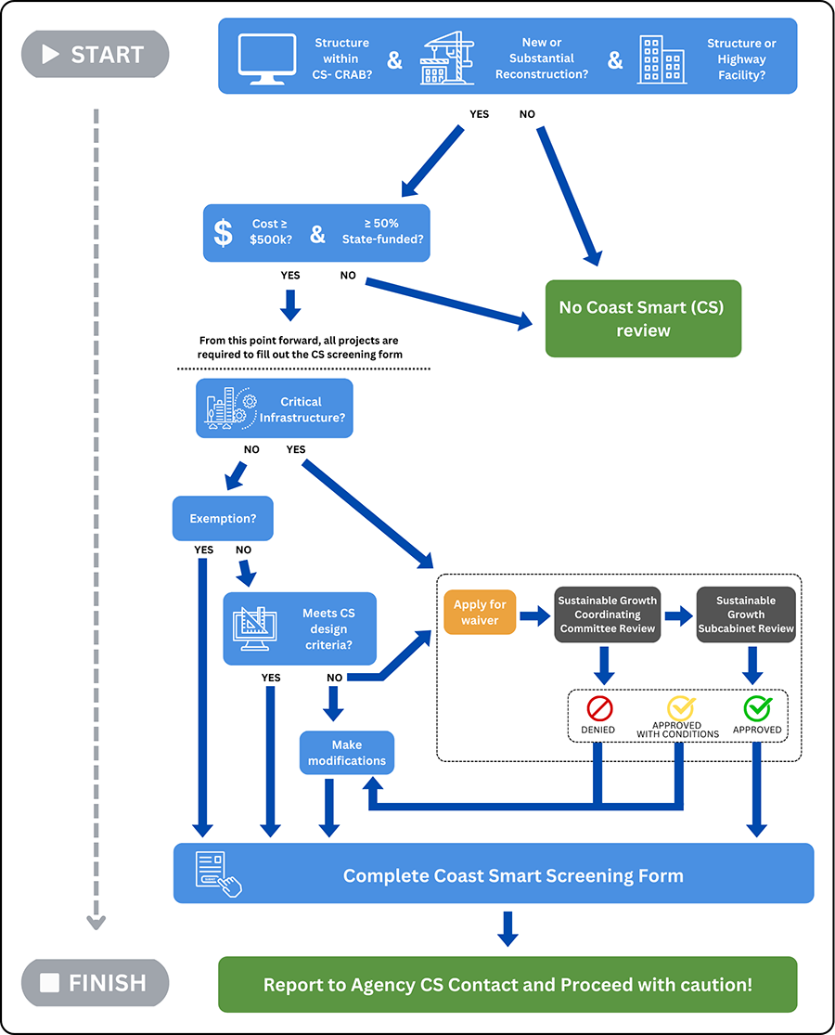
Figure 1: Coast Smart Process Decision Tree. For more detailed information please refer to the Coast Smart website or email the staff facilitator: Ryland.taylor@maryland.gov

Annual Reporting to the Council
Beginning on October 1, 2016 and for every year thereafter, all units of state government are to report to the council on individual state agency actions, which were undertaken within the previous state fiscal year and related to the implementation of the program, including categorical exemptions and waiver determinations.
It is intended that the council will review the program on an annual or “as necessary” basis to integrate emerging Coast Smart planning and construction practices and address issues identified during the building of state facilities. The Annual Report helps the council evaluate the program and supports the further development or refinement of criteria, categorical exemptions, general standards and procedures for applying and obtaining a waiver.

Section I: Legislative Updates
In the 2024 legislative session, Senate Bill 299 was passed to amend the Coast Smart law. This amendment gave the Coast Smart Council the ability to recommend regulations for adoption to the Chair, the Secretary of DNR.
In October 2025, DNR submitted its first set of regulations on behalf of the Coast Smart Council. The purpose of these regulations is to establish the applicability of and process for complying with the Coast Smart Construction Program requirements and define essential terms used throughout the program. The regulations require the use of a screening form for all eligible projects to assess overall project coastal flood resilience and the use of the map to determine project eligibility. Both items are currently utilized as part of the program, but not required in statute. Waivers and categorical exemptions processes are both enabled in this statute, but this regulation establishes definitions as well as the process and justifications for granting them. The final part of the regulation establishes reporting requirements for the program and supporting documents.
The enabling statute of the Coast Smart Council charges the Council with establishing standards and processes. These standards and processes are laid out in the Coast Smart Construction Program Document but are further clarified with these regulations to spell out applicability, definitions, processes, and expectations for projects that are required to comply.
The regulations were finalized and are effective as of December 11, 2025.

Section II: Institutionalizing Coast Smart Siting and Design Criteria into State Programs
Since July 1, 2015, state agencies have been working to incorporate the siting and design guidelines into appropriate planning, design and construction processes as a means to institutionalize the Coast Smart practices approved by the council. Links to meeting notes and presentations referenced below can be found on the Coast Smart website at the meetings link. Advancements in 2025 included:

- Coast Smart Website Update: On April 30, DNR unveiled a major update to the Coast Smart Council’s website. The update included an overhaul of the overall organization of the website, the addition of a video testimony from DNR’s Secretary Josh Kurtz, a section of drop downs that walk people through the basics of the Coast Smart law, and a new decision tree style graphic to walk people through the Coast Smart Construction Program.
- Scientific Updates: At the February 26 meeting the Coast Smart Council heard from Allison Reilly (University of Maryland) about sea level rise impacts on non-housing infrastructure and its potential isolation of rural coastal areas. At the May 28 meeting, Molly Mitchell (Virginia Institute of Marine Science) presented on the challenges of using sea level rise projections in coastal planning.
- Agency Process: The August 27 meeting consisted of a presentation by the Maryland Port Administration about how they are considering flooding vulnerability in their long term asset planning. These facilities are exempted from the Coast Smart Construction Program, but the presentation showed how they are still using the CS-CRAB map to inform their decision making.
- Learning from Other States: At the December 3, 2025 meeting, the Coast Smart Council invited Ned Swanberg from Vermont to talk about their Flood Safety Act passed in 2024. This presentation included information pertaining to riverine flooding and floodplain management which could inform future Coast Smart Council discussions about potential expansion to include riverine flooding.

Section III: State Agency Projects and Grants and Loans Administered by State Agencies
The Department of Budget and Management (DBM) Office of Capital Budgeting (OCB) prepares the Governor’s annual capital budget and develops the five-year Capital Improvement Program, exclusive of Department of Transportation projects. The capital budget consists of state-owned capital projects and grant and loan programs administered by State agencies to support capital projects.
State-owned capital projects are required to be constructed or renovated in compliance with Coast Smart siting and design criteria. All State-owned projects and a few grant and loan program projects are screened based on their location for growth and conservation criteria, including Coast Smart during the development of the capital budget. If OCB indicates a project is in the CS-CRAB layer, the Department of Planning and (MDP) and DNR work with the agency project manager to incorporate Coast Smart siting and design criteria into the facility program. Projects are typically screened several years in advance of funding.
Most grant and loan programs administered by State agencies use internal review processes to ensure compliance with Coast Smart when awarding State capital funds to local projects from their respective programs.
In FY 2026 capital budget Growth and Conservation Criteria process, one State-owned project and 15 grant and loan projects were located within the CS-CRAB boundary. After the initial screening was completed and upon further review by DNR and MDP, the majority of these projects did not meet the applicability criteria for Coast Smart based on the cost and type of project. One project was identified as subject to the Coast Smart law so the agency was contacted to ensure awareness of the requirements.

Section IV: Categorical Exemptions and Criteria Waivers
The program includes provisions for state agencies to apply for Categorical Exemptions for certain project types and uses as well as to request Waivers from one or more of the specific siting and design criteria.

Categorical Exemptions

Under the Categorical Exemptions provision, agencies may determine that certain projects and uses are exempt from strict application of the criteria, provided that it can be demonstrated that those projects have been designed to increase resiliency to future impacts. Categorical Exemptions currently include the following project types and uses:
Water-dependent uses. Projects that require continued direct access to the water as an integral part of the use, or facilities that directly support water dependent uses.
Passive public access. Projects that provide either recreational or scenic access to water bodies or shoreline areas and need to be within a flood zone to accomplish their purpose.
Historic structures. Projects that require the investment of state resources in properties or determined eligible for listing in the National Register of Historic Places or a contributing resource within a historic district listed or determined eligible for listing in the National Register.
Temporary structures or uses. Structures intended to be in place for less than 180 consecutive days in any given calendar year or will be removed at the end of a construction project.
Emergency uses. Structures essential to save lives and protect property, public health and safety.

While categorically exempted projects are excused from strict application of the criteria, they are still required to employ Coast Smart principles and practices, wherever practicable. Agencies using a categorical exemption are also required to submit documentation and reporting materials on an annual basis. Reporting documents will be used by the council for the purposes of further development and/or refinement of Coast Smart Siting and Design Criteria, Categorical Exemptions, or general standards and procedures for applying and obtaining a waiver.

If needed, agencies may request a formal consultation with the Coast Smart Council for the purposes of reviewing a proposed project or seek a determination of compliance with the Categorical Exemption provision listed above.

In FY25, no agencies reported project types or uses as Categorical Exemptions. In addition, no agencies have requested formal consultation with the council for projects funded in FY25.

Coast Smart Criteria Waivers

Any unit of state government may request a waiver from one or more of the specific Coast Smart Siting or Design Criteria. Waiver requests are reviewed and approved by the Sustainable Growth Coordinating Committee (SGCC) in consultation with the council. Agencies seeking Criteria Waivers submit the Waiver Request and supporting information to the SGCC. On an annual basis, the waiver requests will be included in the Sustainable Growth Subcabinet report in a section documenting any coordinating committee decision regarding Coast Smart Construction Policy. Similarly, waiver requests and decisions will be reported annually to the council in this report.

In FY25, the following projects applied for waiver consideration:
- The Department of the Environment:
  - Jersey Island Wastewater Pumping Station Replacements - Crisfield (approved)
  - East Central Avenue Pumping Station Replacement - Federalsburg (approved)

Section V: State Agency Actions and Initiatives
In addition to implementing Coast Smart guidelines for the construction of new state structures, or the reconstruction or rehabilitation of substantially damaged state structures, state agencies provide multiple technical and financial assistance programs to help communities assess their vulnerability to coastal flood hazards, identify natural and nature-based features that improve coastal resiliency and adopt Coast Smart practices into project planning and infrastructure improvements to mitigate coastal flooding, saltwater intrusion, storm surge, and sea level rise. The items listed below contain information on new or updated programs and initiatives.

- Sea Level Rise & Flood Visualizations for Maryland’s Coastal Communities
DNR released the Maryland Coastal Flood Explorer at mdfloodexplorer.org in July of 2025. The tool reflects the best available science from the state’s 2023 sea level rise projections. This non-regulatory tool displays areas prone to sea level rise, high tide flooding, impacted by historic flooding events, and allows users to evaluate depth of tidal flooding at any given location in the coastal zone. The tool provides flood data at 6-inch vertical increments and at a higher horizontal resolution than flood visualization data available at the national-level. Future updates will correspond with state sea level rise estimates, which are currently updated every five years by University of Maryland Center for Environmental Science.
- Flood Awareness Month
Flood Awareness Month, an interagency collaboration between state and federal partners, occurred in April with educational engagements focusing on flood safety, flood mitigation, and flood insurance. Agency staff hosted a number of webinars as well as coordinated a social media campaign to distribute flood awareness content across official platforms. Additionally, the Silver Jackets, a U.S. Army Corps of Engineers supported interagency team focused on flooding, attended a community event in Salisbury, Maryland where they shared flood information and guidance on how to use tools and communicate flood risks with community members.
- MyCoast: Maryland
MyCoast: Maryland serves as a community science platform that enables the state to document, prepare for, and respond to flooding. This online resource creates an important record on how Maryland communities experience flooding from high tides, precipitation, and coastal surge. The photographic evidence and associated data collected through the platform enable government agencies and business owners to make informed decisions about infrastructure improvements, emergency response protocols, and community resilience strategies. Going forward, DNR will continue promoting the tool with local governments and community groups to identify vulnerable areas, validate flood models, and inform adaptation strategies.
- Coastal Resilience Tools Website Update
DNR recently updated their website to consolidate resources for Coastal Resilience planning on a single website. The new Coastal Resilience Tools website contains DNR tools that support multiple planning needs including sea level rise planning, wetlands identification, boating access, and water quality among others. The website also links to other state agency and federal external resources that could be useful in planning efforts as well.

Section VI: Follow-Up Actions and Recommendations
The Coast Smart Council continuously seeks to refine and reassess how the Coast Smart Construction Program is functioning. The below items have been identified as topics that will be pursued in the following year to develop the program further.

- Training and Outreach - Focus outreach efforts to embed Coast Smart Construction Program in local government planning
Over the past year, the Coast Smart Council has done a substantial amount of outreach with state agencies to raise awareness of the Coast Smart Construction Program and to better embed its requirements within programs that may fund projects required to comply. Over the next year, the Coast Smart Council will continue to provide outreach and training on the Coast Smart Construction Program with a concentrated focus on local government education and compliance to include how to best prepare, mitigate and repair flood prone areas that are projected to be impacted by future climate events.

- Coast Smart Construction Program Document Updates - Review and update the Coast Smart Construction Program’s siting and design guidelines and project screening form
The Coast Smart Council was charged with creating siting and design criteria for the Coast Smart Construction Program, but the information used to make these determinations will not remain static. The Coast Smart Council will take a deeper look at the information in the Coast Smart Construction Program document and begin the process of updating the siting and design criteria as well as the project screening form.

- Riverine Expansion - Scope the potential expansion of the Coast Smart law to encompass riverine flooding impacts
Riverine flooding has had significant impacts on communities across Maryland including those in the interior of the state that are not subject to the Coast Smart criteria as the law is currently written. The Coast Smart Council will consider the state of the science of riverine mapping and the processes needed to integrate into the current Coast Smart Construction Program’s siting and design criteria.

