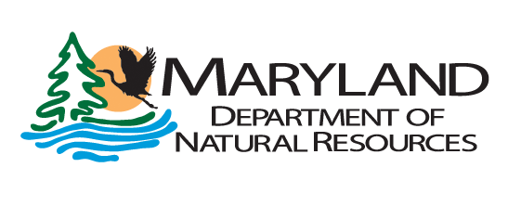
Community Parks and Playgrounds (CP&P) Program

FY2024 Grant Proposal List

APPLICANT INFORMATION:

APPLICANT:
(Name of Municipality or Baltimore City)

PROPOSED PROJECT(S):
For each project listed, please provide a complete application packet.

List PRIORITY (#1 highest, etc.) | PROJECT TITLE | FUNDS REQUESTED
1. |  | $

DECLARATION OF ADHERENCE TO AWARD CONDITIONS/REQUIREMENTS

I have read and agree to adhere to all award eligibility requirements and conditions for all submitted projects including:

- All projects must be consistent with National Playground Safety Standards and with the Americans with Disabilities Act.

- All projects must have a minimum twenty (20) year life span. Conversions of project use will require replacement with a project of equal or greater recreational use, acreage (in the case of acquisition projects) and equal or greater monetary value approved by the Community Parks and Playgrounds Program.

3. All projects are within the applicant’s jurisdiction and the applicant holds the right to develop on the property.

LOCAL GOVERNMENT AUTHORIZATION
Community Parks and Playgrounds projects are to be administered in accordance with the Program Open Space (POS) Grants Manual. As the authorized representative of this Political Subdivision, I read the terms of the “Project Agreement and General Conditions” of the POS Grants Manual and I agree to perform all work in accordance with the Manual, POS Law and Regulations, Special Conditions of the Community Parks and Playgrounds Program and with the attachments included herewith and made a part thereof.

Signature
Print Name
Title
Date

